Lab 5 - Spectral Analysis
Name: Wenqian Ye
NetID: wenqian3

1.Report item1
Implement a function called myMatrixDFT that implements the DFT using matrix-vector multiplication by constructing the DFT matrix. Validate your function with fft. Based on your implementation, why does it make sense that the DFT is O(N 2 )?
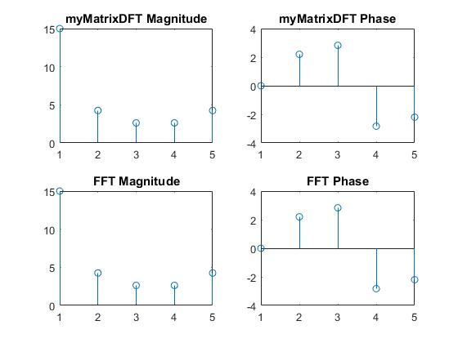
The figure looks the same.
Comparing myMatrixDFT() with fft() as shown below the difference is 10^-9 hence these can almost be equal.
I used for loop to iterate the dft in MyDFT function so the running time should be N*N that's O(N^2).
2.Report item2
Load signal.mat. A variable called x should appear in your
workspace. Using fft, find X(ω) and plot its magnitude and phase. Given that fs = 200 Hz, find X d (Ω) and plot the magnitude and phase. How many frequency tones are there? What are their values (in Hz)?
There are 5 frequency tones. I used data cursor on matlab finding the values. Their values are about 30, 142, 205, 280, 310.
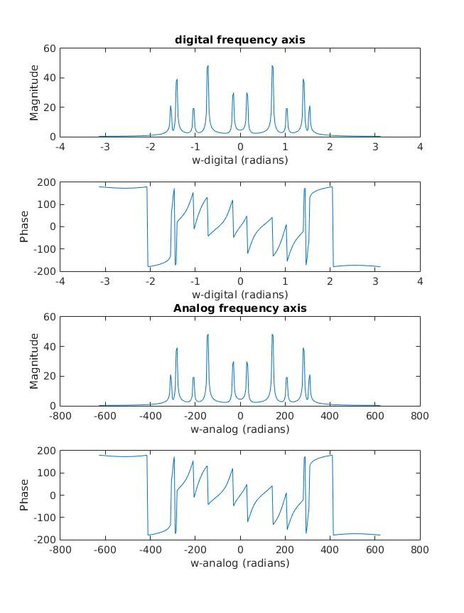

3.Report item3

Load NMRSpec.mat. The sampling frequency of the NMR signal is f s = 2000 Hz. Plot the magnitude and phase spectrum of the signal (hint: MATLAB’s fft can perform zero-padding). Calculate the 32-point DFT spectrum of the first 32 points of the signal. Can you distinguish the peaks corresponding to creatine (around 209 Hz) and chlorine (185 Hz)? Zero-pad the signal to 512 points and plot the resulting magnitude and phase spectrum. Does zero-padding help? Why or why not?

We cannot distinguish the peaks at creatine and chlorine. Zero-padding does not help, because it only extends the current spectrum to a new range.
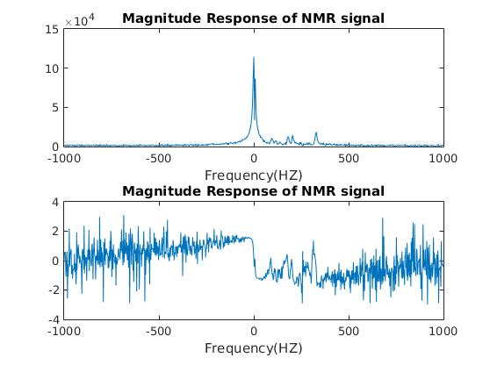
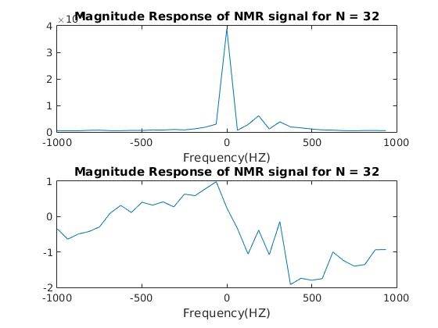
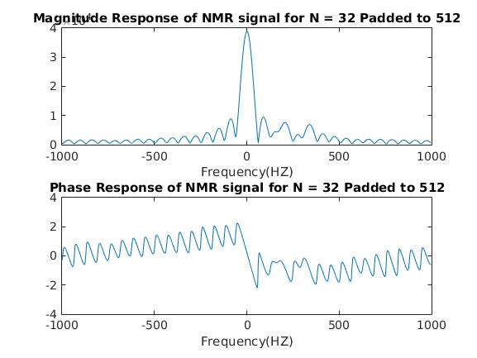

4. Report Item4

The triangular and rectangular windows have the same mainlobe width.
The triangular window has lower sidelobes than rectangular does.
The hamming window has lower side lobes than the rectangular window.

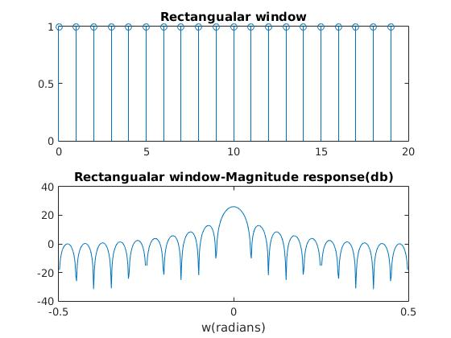
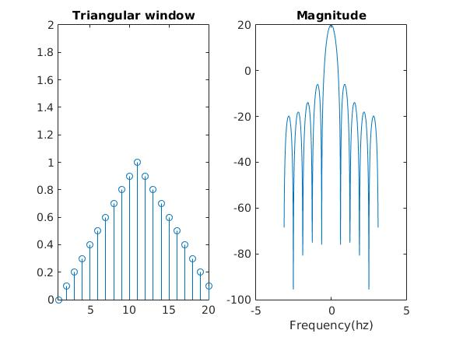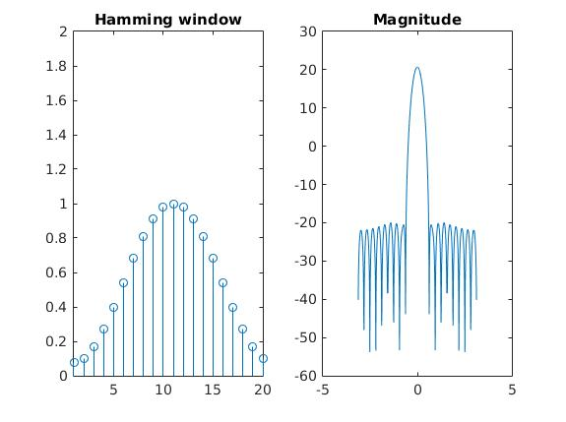

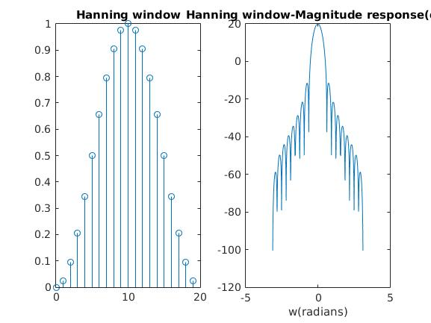

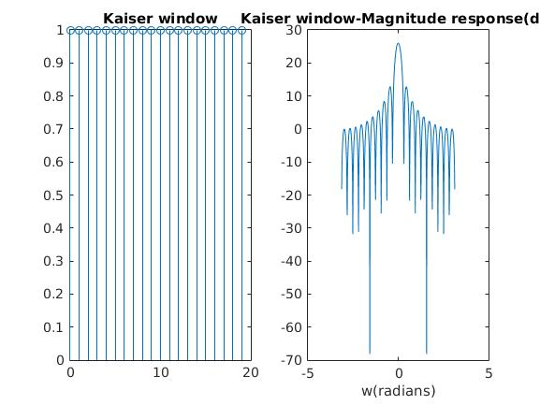

5.Report Item5
For N = 20, the mainlobe width is 0.627 radians.

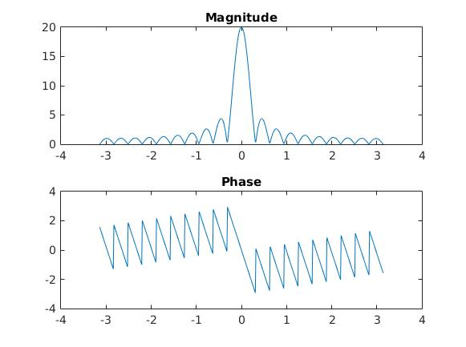

For N = 40, the mainloabe width is 0.3074 radians.

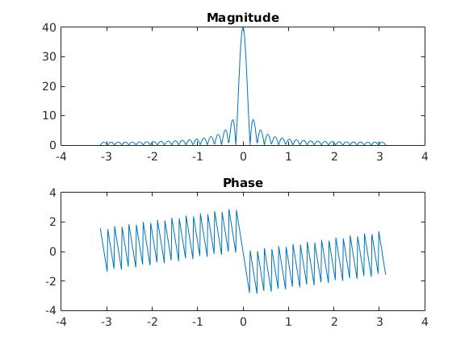

6.Report Item6
To minimize spectral leakage N =(1 / 0.02 ) / 5 = 10
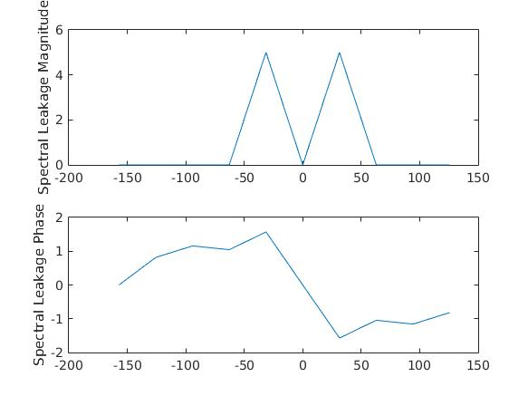

7.Report Item 7
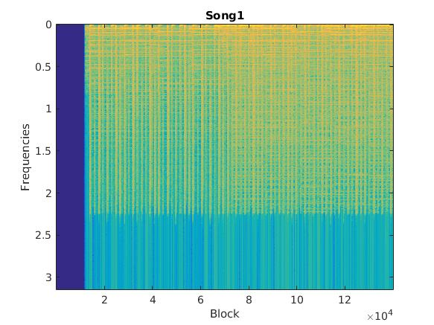

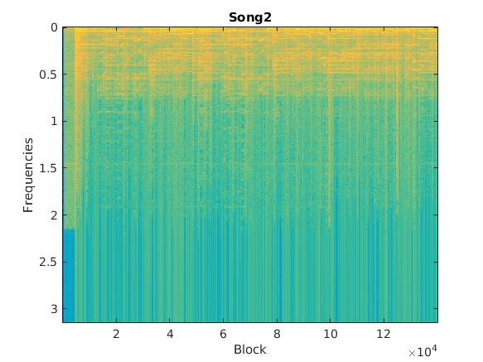
The color indicates the intensity of sound.

For the first one:
There is no sound for the 1st second, then we can hear a more 'drum' sound because the blue color in each block indicates a impluse which correspond to the drum.
For the second one:
This seems like a guitar song. Because the guitars contain chords so the sound will decay by time. The yellow decays when the block increasing and the color turning from yellow to blue.

